Sign in to Windows virtual machine in Azure using Microsoft Entra ID and Azure Roles Based Access Control
Authentication requirements:
Its supported for Windows Server 2022 Datacenter Azure Edition.
Microsoft Entra Guest accounts can't connect to Azure VMs, need to create member accounts.
1. Enable Entra login via extension.
Creating a new VM:
Entra login can be enabled automatically during the resource creation process. Under the Management tab, select Login with Microsoft Entra ID. This will also select the Enable system-assigned managed identity option. If, for some reason, this does not get checked, you can do it manually or enable it after the VM has been created.
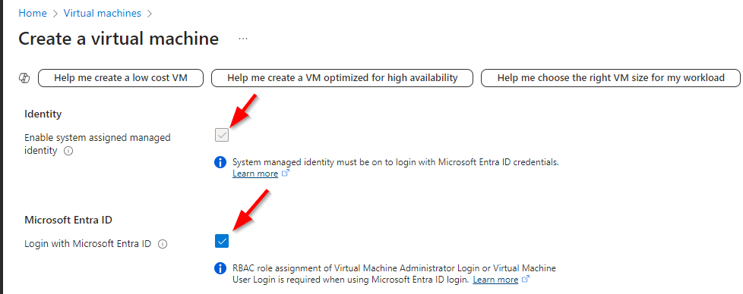
Existing VM:
Enable system-assigned managed identity if not already On.
Browse to the VM and go to Security -> Identity. Toggle the switch to On and click Save.
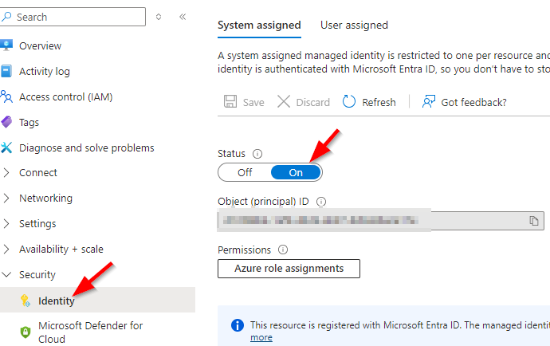

Browse to the VM and go to Settings -> Extensions + applications on the left menu. From there, click Add.
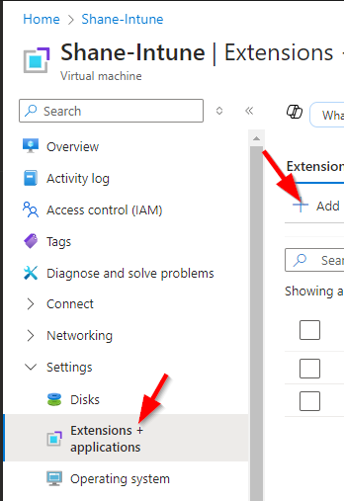
Search for Azure AD-based Windows Login. Select the extension and click Next -> Review + Create -> Create.
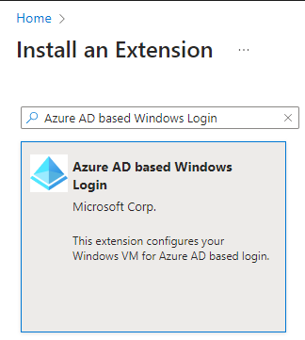
2. Verify extension is installed and update it if necessary.
Browse to the VM and go to Settings -> Extensions + applications on the left menu. We should see the extension listed as either AADLoginForWindows or AADLogin.
When installing the extension through the create resource process, it will often name the extension AADLoginForWindows and AADLogin when adding the extension to an existing VM.
If it shows that an update is available, select the extension and choose Update.
AADLoginForWindows and AADLogin when adding the extension to an existing VM.
If it shows that an update is available, select the extension and choose Update.
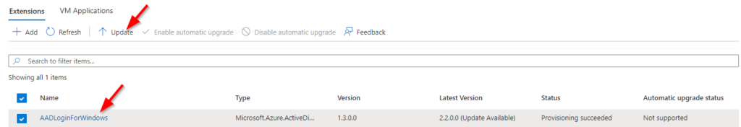

4. Ensure users have proper roles to log in with Entra credentials.
Users must have one of the following role assignments:
Virtual Machine User Login
- Gives user permission to log in as a regular user
Virtual Machine Administrator Login
- Gives user permission to log in as an administrator.
These roles can be assigned directly to the user for each specific VM or to a group with the role assigned and added to the VM. The roles can also be inherited from roles assigned at the Subscription, Resource Group, or Management level.
To verify if a user has the proper permissions, browse to the VM, go to Access Control (IAM), and choose Check Access. Search for and select the user and verify that one of the above roles is assigned. If not, that user cannot log in with Entra credentials.
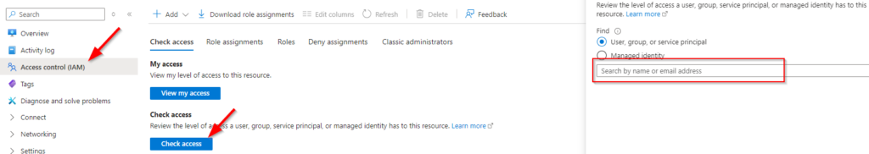

5. Now, we can access the VM through VPN or Bastion. but its required some additional steps-
1. Need to make a entry in the host file with VM private Ip VM Name
Example- 10.255.254.7 test-windows-vm

2. Need to edit RDP file, in the general section-
Computer name- VM Name
Username- member account username
Advance section- we need to enable user authentication to- use a web account to sign in to remote computer

Note: If required, create conditional access policy in Entra id and assign that policy to Entra id member account user.
Additionally, need to enable MFA if required in the conditional access policy.

To create an Azure Entra Conditional Access policy, you need a Microsoft Entra tenant with P1 or P2 licenses, a user with at least the Conditional Access Administrator role.

# Azure Document link for the reference: https://learn.microsoft.com/en-us/entra/identity/devices/howto-vm-sign-in-azure-ad-windows?pivots=identity-extension-vm

